**GUIDELINE RELATING TO DISABILITY**

**FRIENDLY REPRODUCTIVE HEALTH AND SAFE MOTHERHOOD SERVICE,**

2022



GOVERNMENT OF NEPAL MINISTRY OF HEALTH AND POPULATION

HEALTH SERVICE DEPARTMENT FAMILY WELFARE DIVISION TEKU, KATHMANDU

**ttcHaft Sl\ilq 8l96·**

**'tr'=..**

**o,-a- , a**

. **Bhawani Prasad Khapung**

**tfclltta (fllT ijiil (._&ll**

**Government of Nepal**

***\el* 01-4-262534**

**Qllicf\l: o,-a- , ,**

**Fax: 01-4 - 262565**

**Website:** [**www.mohp.gov.np**](http://www.mohp.gov.np/)

**Minister for**



--

·

**Health and Population**

**ta Ref. No.):**

**tdltW clWI Jldltl&ffell cHir311c1.ZJ**

**Ministry of Health and Population**

**if.(Dispatch No.):**

C

**'(ififll,QQ, cfil6'11Ji,**

**Ramshahpath, Kathmandu, Nepal**

**filftr{Date)**:............................... **.**

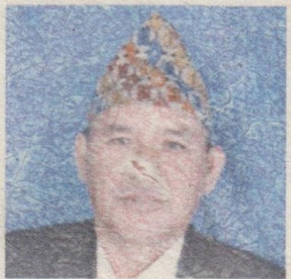

##### BEST WISHES

"The Ministry of Health and Population is committed to making health services accessible to persons with disabilities in accordance with the Constitution of Nepal, 2015, which states that every citizen shall have equal access to health services. In order to create an environment where available health services are equally accessible to persons with disabilities, the structures of health institutions are being constructed and strengthened to be disability-friendly. The Ministry is also committed to including content related to skills for providing disability-friendly health services in medical education and training curricula to develop the communication skills required when communicating with persons with disabilities.

After the implementation of the Disability-Friendly Safe motherhood and Reproductive Health Service Operation Directives, 2022, issued for the Enforcement of the constitutionally guaranteed right to equality and the provisions of The Right to Safe Motherhood and Reproductive Health Act, 2018, which mandates reproductive health services to be adolescent and disability-friendly, I believe that persons with disabilities will have equal access to health services provided by government and private health institutions, as other individuals.

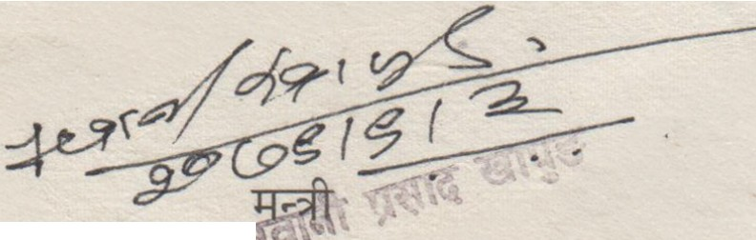I would like to express my heartfelt gratitude to the Health Service Department, Family Welfare Division, who prepared this directive, and to all the relevant individuals who have provided recommendations, feedback, and technical assistance regarding this.

18TH DEC 2022

BHAWANr RASAD KHAPUNG MINISTRY OF HEALTH AND POPULATION



ta :­

ta :­

if.:-

lfiTifif.

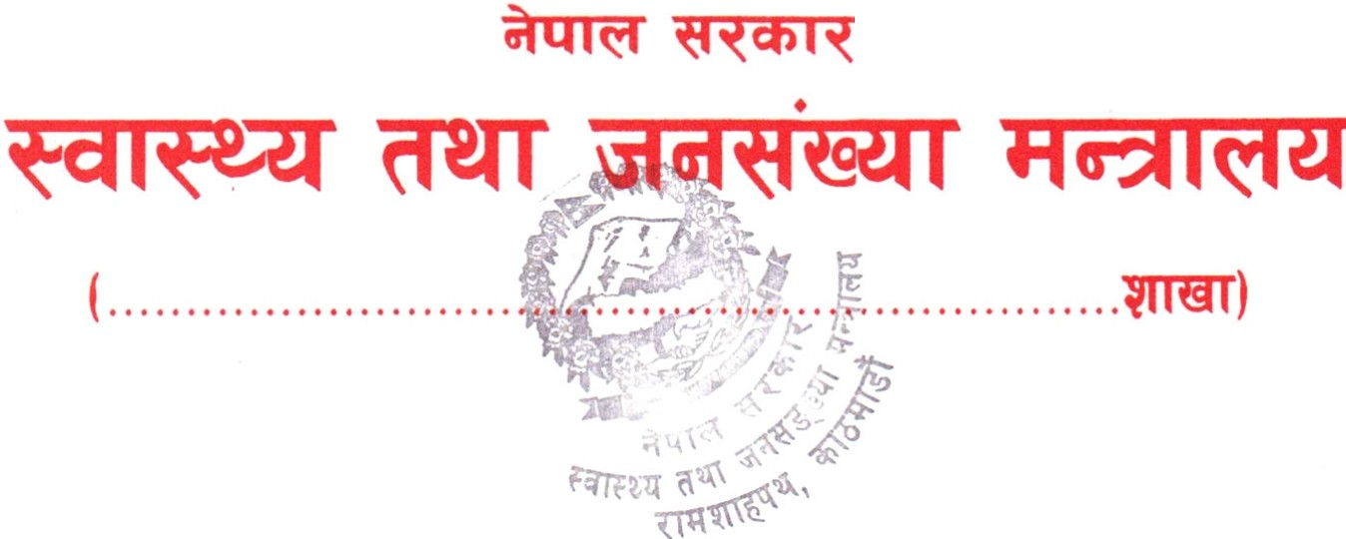 **1'1 11 Q ,**

**cfilot1lti,**

**8 ft t!0**

8 ft to

**8 ft '-'0ft**

**8 ft t!**

**8 ft tft**

* **,a to**

I

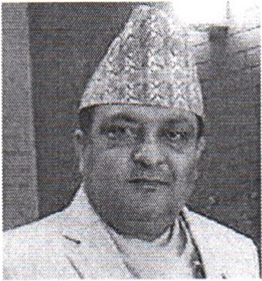**fcltSlll**

#### STATEMENT

Various activities have been conducted by the Ministry of Health and its subordinate bodies to make health services inclusive and accessible through the implementation of citizens' rights to equal access to health services as provided by the Constitution of Nepal, 2015. The task of Disability-friendly health institutions is being constructed, and old building are being renovated, it is necessary to add subject matter of communication skills in the medical education curriculum and training curriculum in order to develop the communication skills required while communicating with persons with disabilities.

I believe that after the implementation of the Disability-Friendly Safe Motherhood and Reproductive Health Service Operation Guideline, 2022, which were issued incorporating provisions regarding standards for disability-friendly healthcare structures, the competence of communication skills for service providers in accordance with the needs of persons with disabilities, the development of disability-friendly health education, information, and communication materials, and the provision for the accommodation of healthcare materials for service recipients with disabilities, persons with disabilities will receive quality healthcare services on an equal basis.

Finally, I extend my gratitude to the Family Welfare Division for preparing these directives and to all those who provided suggestions and recommendations.

18TH DEC 2022

**DR. -POKHREL**

SECRETARY

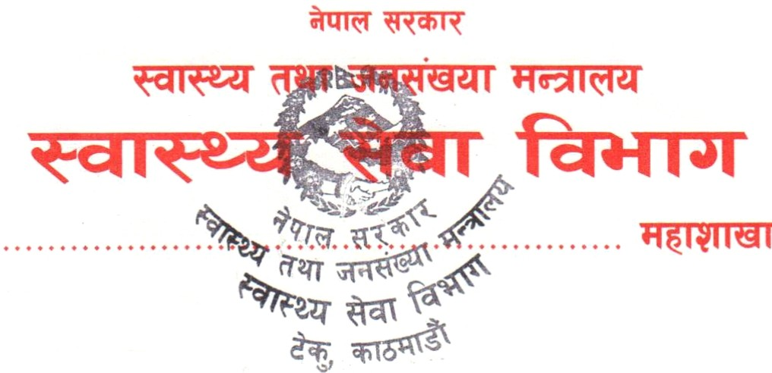**Cl 8- 'll,'I**

**iii 8- '18**

**lfmcffl: 8- r;**

.

tlilo•ulf, 1

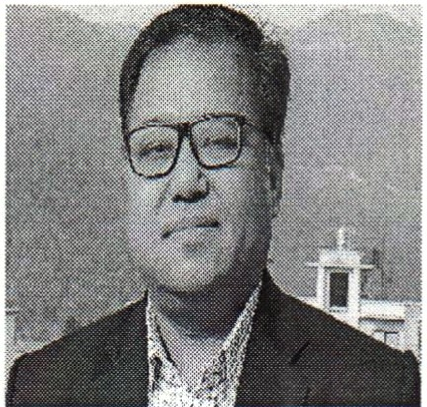

##### BEST WISHES

The Constitution of Nepal, 2015, has arranged the provision that every citizen shall have equal access to the right to health services. Even though health services are available to the general public, due to the lack of communication skills in accommodating persons with disabilities among service providers, and also due to the fact that not all Health institutions structures are disability-friendly, persons with disabilities are facing barriers in receiving healthcare services.

The Disability-Friendly Safe Motherhood and Reproductive Health Service Operation Guideline, 2022, have been issued with the objective of creating an environment where persons with disabilities can receive healthcare services unobstructed, incorporating provisions for the accommodation of healthcare structures for service recipients with disabilities, the development of communication skills required for interacting with persons with disabilities, and the creation of disability-friendly information and communication materials.

Finally, I would like to thank the Director of the Family Welfare Division and all the involved staff for preparing the directive, including subject matter experts, representatives of the partner agencies, and all others.

*R_J5*

DR. DIPENDRA RAMAN SINGH

DIRECTOR GENERAL





ifNR":-

**Cl 8- fr<t\9<t**

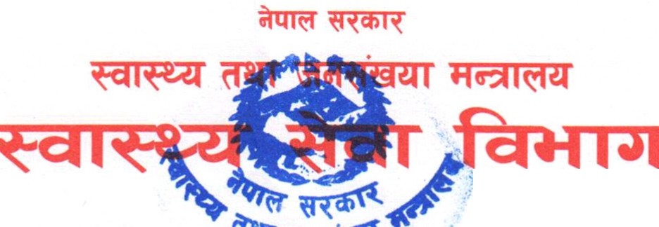**iii** 8- 1:rci8a1:r

: **8- fr frt**

......................... . ............. **'1 1,11&1** .

i:filo•Us\ I

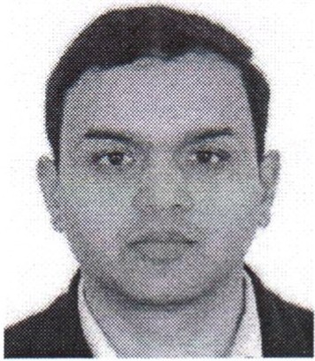**FOREWORD**

Being a citizen of Nepal, it is a constitutional right of the person with disability to get health services including family planning, reproductive Health, safe motherhood, safe abortion, emergency delivery and newborn infant, reproductive health morbidity on the equal basis with others. It is necessary to assist individuals with disabilities, who make up nearly 2 percent of the total population, in accessing health services, including safe motherhood, by reducing existing structural and communication barriers in the healthcare system.

The Disability-Friendly Safe Motherhood and Reproductive Health Service Operation Guideline, 2022, have been prepared to make health services provided by government and private health institutions accessible to persons with disabilities by building health structures and strengthening them in a way that is accommodative to individuals with disabilities, developing appropriate communication skills among service providers, and developing disability-accommodative information and communication systems.

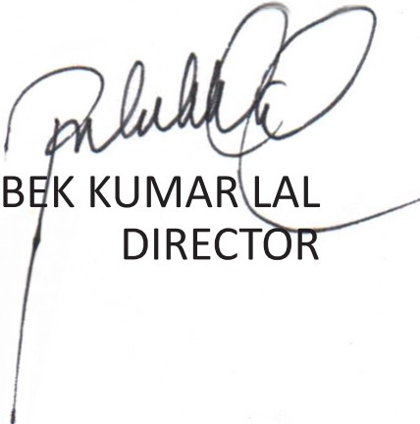I would like to express my heartfelt gratitude to Mrs. Kavita Aryal, Head of the Family Planning and Reproductive Health Section, involved in formulating these guidelines, including the staff of this section, the National Health Education Information and Communication Center, the National Health Training Center, the Director and other staff of the Epidemiology and Disease Control Division, the representatives of the Blind Youth Association Nepal, partner organizations, and the respected Secretary Dr. Roshan Pokharel and the respected Director General Dr. Dipendra Raman Singh for their contributions during the preparation of the directives.

DR. Bl

# TECHNICAL ASSISTANCE FOR DIRECTIVE WRITING

Mrs. Kavita Aryal, Senior Community Nursing Administrator, Family Welfare Division

Mr. Pushparaj Joshi, Statistical Officer, Family Welfare Division Mr. Kaladhar Bhandari, President, Blind Youth Association Nepal

Mr. Ramchandra Gaire, Secretary General, Blind Youth Association Nepal Mr. Bishwa Ram Shrestha, Program Director, Blind Youth Association Nepal Mr. Shiva Bahadur Rayamajhi, Expert

Contributors for advice, recommendations, and writing

Dr. Roshan Pokharel, Secretary, Ministry of Health and Population Dr. Dipendra Raman Singh, Director General, Department of Health Services

Dr. Bibek Kumar Lal, Director, Family Welfare Division

Mr. Sunilraj Sharma, Director, National Center for Health Education, Information, and Communication center

Dr. Yadu Chandra Ghimire, Director, National Health Training Centre Mr. Kunj Joshi, Senior Health Education Administrator, National Health Training Centre

Mrs. Sheela Shrestha, Senior Health Education Administrator, National Center for Health Education, Information, and Communication center Mr. Shambhu Niraula, Law Officer, Department of Health Services

Mrs. Amrita Pahadi, Senior Community Nursing Officer, Family Welfare Division

Mrs. Nisha Joshi, Senior Public Health Officer, Family Welfare Division Mrs. Lakshmi Pandey, Senior Community Nursing Officer, Family Welfare Division

Mr. Om Khanal, Public Health Officer, Family Welfare Division

Mrs. Tulsa Devi Adhikari, Nursing Inspector, Family Welfare Division Mr. Bishnu Baskota, Public Health Inspector, Family Welfare Division Mr. Navraj Bhattarai, Consultant, Family Welfare Division

Mr. Binod Joshi, Monitoring and Evaluation Officer, Family Welfare Division

### ORGANIZATION'S INVOLVEMENT

* + World Health Organization (WHO)
  + UNICEF
  + UNFPA
  + PSI Nepal
  + Nepal Family Planning Association
  + ADRA
  + Marie Stopes International
  + USAID, Knowledge SUCCESS Proofreading & Verification:

Mr. Bhavnath Khatiwada, Deputy Secretary, Department of Health Services

# PREAMBLE

Whereas, it is expedient to make safe motherhood and reproductive health services, provided by health institutions, accessible to persons with disabilities,

pursuant to the authority conferred by Section 40 of The Right to Safe Motherhood and Reproductive Health Act, 2018,

Now, therefore, this directive is enacted and promulgated by the Government of Nepal, Ministry of Health and Population.

#### CHAPTER-1

**Preliminary 1) Short Title and Commencement:**

1. The name of this directives is 'Disability Friendly Safe Motherhood

and Reproductive Health Service Operation guideline 2022.

1. This Directives shall come into force immediately.
2. **Definitions:**

Unless the subject or context requires, in this directive,

* 1. "Accommodation" refers to the arrangement made to ensure accessibility according to the nature of disability.
  2. "Disability" refers to the condition resulting from a complete or partial loss to any part of the body or bodily function, and the limitation and restriction placed on the person by the society due to such loss.
  3. "Persons with disabilities" refers to a person who has long-term physical, mental, intellectual or sensory disability or functional impairments or existing barriers that may hinder their full and effective participation in social life on an equal basis with others.
  4. "Disability friendly" refers to the condition where health services available in health institutions can be utilized by service recipients in an easy and friendly environment.
  5. "Commode" refers to a toilet designed in such a way that it allows one to sit and urinate in a manner similar to sitting on a chair."
  6. "Captioning" refers to the methods of providing the information in any subject matter or words expressed during communication in a simultaneously written form as text.
  7. "Guardian or Curator" refers to a guardian as defined by the prevailing law, and this term also refers to the person who brings the service recipient to the health institution.
  8. "Tactile communication" refers to A form of sign language communication where the sender and receiver exchange information and understanding with each other through the touching of fingers.
  9. "Tactile Path" refers to a specially designed pedestrian pathway with tiles/blocks that can be touched with a white cane, in order to make it easier for Blind or visually impaired individuals to travel.
  10. "Accessible" Refers to the situation in which persons with disabilities, through the improvement of physical structures, tools and equipment, health education, information and communication technology, and materials, can utilize health services independently, without any barriers, on an equal basis.
  11. "Provincial Ministry" refers to the provincial level ministry that oversees health-related matter.
      1. "Division" refers to the Family Welfare Division.

1. "Ministry" refers to the Ministry of Health and Population of the Government of Nepal.
2. "Ramp" Refers to the inclined plane constructed to facilitate easy, safe, and suitable movement for wheelchair users, crutch users, pregnant women, and senior citizens.
3. "Management Committee" refers to the Health Institution Operation and Management Committee and the Hospital Development Committee. This term shall also include the Board of Directors and the proprietor of private health institutions.
4. "Service" "Refers to services related to family planning, reproductive health, safe motherhood, safe abortion, emergency delivery, newborn and infant care, and reproductive health morbidity. This term also refers to services related to infertility management.
5. "Service Recipients" refers to the persons with disabilities who seeks services.
6. "Local government" refers to the metropolitan cities, sub-metropolitan cities, Municipalities and rural municipalities.
7. "Health institution" refers to the health institution operated by the federal, provincial, and local governments. This term shall also include private hospitals, non-governmental hospitals, cooperative hospitals, and non-profit community health institutions established under the prevailing laws.

## CHAPTER-2

**Procedure for Operating Disability-Friendly Services 3. Operation of Services:**

* 1. The services provided by every health institution must be

disability-friendly.

* 1. the services provided by health institutions shall be gradually made disability-friendly, by strengthening the physical infrastructures of health institutions and providing training to the healthcare personnel, in coordination and collaboration with the Government of Nepal, provincial governments, and local levels.
  2. Prior to expanding services in accordance with sub-Section (2), the management committee and relevant stakeholders shall be oriented on disability-friendly services.
  3. While providing counseling and services to the service recipients, methods and procedures as prescribed under Schedule 2 must be adopted in an accessible and adaptive manner, in accordance with the classification of disabilities specified in the Schedule 1 of the Act Relating to the Rights of Persons with Disabilities, 2017.
  4. The Government of Nepal and provincial governments shall provide training to healthcare personnel and other employees to develop the necessary communication skills required for providing services pursuant to sub-Section (4).

1. **Services to be provided with a Dignified Manner:**
   1. The concerns of the service recipients must be listened to patiently, and services must be provided with due respect.
   2. the service recipients must be assisted in reaching their own decision, by providing Information regarding services in an appropriate and accommodative manner, in accordance with the classification of disabilities
   3. words, gestures or signals should not be used in a manner which may lower the morale, cause discomfort, or be perceived as discriminatory or hamper the dignity of the service recipients.
   4. the appropriate disability-related terminology as specified in Schedule 3 must be used while providing services to the service recipients, expressing opinions about persons with disabilities, making comments, delivering presentations, or engaging in conversations.
2. **Provisions Relating to Confidentiality:**
   1. confidentiality shall be maintained by a Health institutions about health condition of the service recipients, diagnosis, treatment received by them, and other related information while delivering services.
   2. Provisions shall be made to maintain confidentiality while providing counselling or services to the service recipients.
3. **Priority to be given:**

(1.) Based on the health conditions of patients and other service recipients visiting the health institution, services shall be rendered by prioritizing those service recipients with disabilities. (2.) Health institutions or local levels shall provide service to the

Individuals with complete disabilities and those with severe disabilities at their residence or within the community.

(3.) individuals with complete disabilities and severe disabilities shall be provided services at the disaster site During natural or non-natural disasters.

(4.) In cases where services cannot be provided pursuant to the sub-sections (2) and (3), necessary arrangements shall be made to transport the service recipients to and from the health institutions.

(5.) Local governments may provide additional incentives to the service providers for rendering services as per sub-section (2).

1. **Free Services:**

Individuals with complete disabilities and severe disabilities shall not be required to pay any registration fees, service fees, diagnostic, therapeutic, or any other associated charges to access healthcare services.

1. **Additional Benefits:**

Pregnant women with complete disabilities and severe disabilities shall be provided an additional amount on top of the amount allocated for maternity incentive and maternity nutrition.

1. **Provision of Assistance Desks and Support Personnel:**

(1.) an assistance desk should be established in the health institutions to facilitate access to service for the service recipients.

(2.) In the Health institutions where a Social Service Unit is established, the same unit should also be designated as the Disability Assistance Desk.

(3.) The assistance desk, as established under sub-section (1), should be equipped with essential assistive devices such as wheelchairs, white canes, crutches, and other necessary support materials.

(4) The health institution or local government may, in accordance with the classification of disability, arrange for support persons or sign language interpreters to facilitate the provision of services in an accessible manner to the service recipients. Such facility should be located in the room on the right side of the main entrance.

1. **Accessible Structures:**
   1. The structures of health institutions should comply to the standards prescribed in Schedule 4, in a manner to facilitate easy navigation and access of health services for persons with disabilities
   2. Such facilities shall be incorporated by modifying the incompatible health institutions pursuant to the sub-Section (1)
2. **Accessible Health Education, Information, and Communication Materials:** (1) The Government of Nepal, Provincial Governments and Local levels should prepare reproductive health education, information, and communication materials accessible to the service recipients in accordance with Schedule 5.
3. **Accessible Digital Content or Website:** (1) The websites of the Government of Nepal, the Provincial Government, and the Local Government should be easily browsable, developed complying the Web Content Accessibility Directives, and designed in Unicode, in accordance with the EPUB method, with a proper color contrast.

(2) The information materials provided on the websites as specified in sub-Section (1) should be in an accessible PDF format, large fonts and accompanying by pictorial signals.

1. **Procurement of Accessible Health Materials:**

The Government of Nepal, Provincial Government and Local Government should, to the extent possible, procure reproductive health service-related medicines, equipment, and materials that are accessible to use for the persons with disabilities.

1. **lnclusion in Curriculum:**
   1. The curriculum in the subjects of medical education shall include matters relating to the necessary skills for providing disability-friendly services.
   2. The training curricula provided by the Government of Nepal and the Provincial Government shall include subject matter on the skills necessary to provide disability-friendly services.
2. **Participation in Policy Formulation and Planning Process:**
   1. The participation of persons with disabilities or their representative organizations should be mandatory in the formulation and interpretation of policies and plans related to disability-friendly health services.
   2. participation should be made from a person with disability or an organization as an invited member in the management committee meetings.
3. **Budgetary Management:**

The Federal Government, Provincial Governments and Local Governments should allocate the necessary budget to render the disability-friendly services provided by the health institutions.

### CHAPTER-3

**Functions, Duties and Powers of various entities: 17.Ministry of Health and Population:**

1. To formulate policies relating to disability-friendly safe motherhood

and reproductive health.

1. To allocate the necessary budget for operating disability-friendly services.
2. to coordinate multi-sectoral for the operation and expansion of disability-friendly services.
3. To initiate the inclusion of subject matters relating to the skills required in the medical education curriculum for providing services to the persons with disabilities.
4. To include subject matters relating to the skills required for providing services to persons with disabilities in the training curriculum provided by the Government of Nepal.
5. To make the participation of representatives of persons with disabilities or their organizations in the policy formulation and planning process.
6. **Family Welfare Division, Department of Health Service:**
   1. To develop orientation and training materials related to the operation of disability-friendly services.
   2. To enhance the capacity and skills of service providers with respect to disability-friendly safe motherhood and reproductive health services.
   3. To operate and expand disability-friendly safe motherhood and reproductive health services in the health institutions at the central level.
   4. To conduct orientation programs for stakeholders in order to operate and expand disability-friendly services.
   5. To conduct regular monitoring of disability-friendly health services. While conducting such monitoring, representation of persons with disabilities or their organizations should be included.
   6. To prepare or cause to be prepared information, education and communication materials accommodating to the service recipients in an accessible method and appropriate format.
   7. to initiate necessary modifications in record-keeping and reporting forms to maintain disaggregated records of disability-friendly services.
   8. To arrange for the entry of reports of services provided to service recipients into the Health Management Information System

(I) To make participation of representatives of persons with disabilities or their organizations in the meetings of the Reproductive Health Coordination Committee and the Adolescent-Friendly Health Technical Committee.

1. **Provincial Ministry:**
   1. To formulate province-level policies regarding disability-friendly safe motherhood and reproductive health.
   2. To include disability-friendly safe motherhood and reproductive health related activities in the annual budget and programs.
   3. To make participation of representatives of persons with disabilities or their organizations in the formulation and planning process of disability-related policies.
   4. To initiate the inclusion of subject matters relating to the skills required in the medical education curriculum to provide services to persons with disabilities.
   5. To include subject matter relating to the skills required in the training curriculum to provide services to persons with disabilities.
   6. To operate and expand disability-friendly safe motherhood and reproductive health services in subordinate health institutions.
   7. To provide feedback by monitoring whether the services provided by health institutions are disability-friendly.
2. **Health Directorate:**
   1. To conduct, and cause to be conducted the implementation of orientation programs at the provincial level regarding disability-friendly safe motherhood and reproductive health.
   2. To enhance or cause to be enhanced the skill of health workers on the subject of disability-friendly safe motherhood and reproductive health.
   3. To maintain a disaggregated record of the services provided to service recipients with disabilities and to arrange for the entry of such records into the Health Management Information System.
   4. To provide feedback by monitoring whether the services provided by health institutions are disability-friendly.
   5. To make participation of representatives of persons with disabilities or their organizations in the management committee meetings.
3. **Local Government:**
   1. To formulate policies regarding disability-friendly safe motherhood and reproductive health.
   2. To expand disability-friendly safe motherhood and reproductive health services in subordinate health institutions.
   3. To make participation of representatives of persons with disabilities or their organizations in the formulation and planning of

disability-related policies.

* 1. To conduct or cause to be conducted orientation programs for stakeholders prior to the operation of disability-friendly services.
  2. To provide training to service providing health workers and to enhance their skills.
  3. To provide feedback by monitoring whether the services provided by health institutions are disability-friendly.
  4. To maintain a disaggregated record of the services provided to service recipients with disabilities and to arrange for the entry of such reports into the Health Management Information System.
  5. To make participation of representatives of persons with disabilities or their organizations in the management committee meetings.

1. **Provision Related to Monitoring:**
2. The Government of Nepal, the Provincial Government, and the Local Government shall from time-to-time monitor whether the services provided by health institutions are disability-friendly, including monitoring aspects such as service quality, physical infrastructure, medicines, instruments and equipment and human resource management, among others.
3. The checklist provided under Schedule 6 shall be used in conducting the monitoring pursuant to sub-Section (1).

## CHAPTER-4

**Miscellaneous**

1. **Record Report:**
2. The record report form shall be modified to keep the records of services provided by health institutions in a disaggregated manner.
3. Records of the services to be provided by the health institutions shall, while being maintained in the prescribed forms in a disaggregated manner, be entered into the Health Management Information System on a monthly basis.
4. The health service card shall be printed in a manner that is accommodating and reasonable as per the classification of disability.
5. invalidity: The provisions mentioned in this directive shall be deemed invalid to the extent that they are inconsistent with the prevailing laws of the Government of Nepal.
6. Authority for Interpretation of the Directive: In case any ambiguity arises regarding the application of this directive and requires interpretation, the interpretation of the Ministry shall be final.
7. Amendment of the Directive: The Ministry may amend the directive from time to time.

# SCHEDULE 1

**(Related to Sub-Section (4) of Section 3)**

**Classification of Disability as per The Act Relating to Rights of Persons with Disabilities 2017**

1. **Persons with disabilities according to the problem and difficulty in any organ or system of the body:**
   1. Physical disability: Problem that arises in operation of physical parts, use and movement in a person due to problems in nerves, muscles and composition and operation activities of bones and joints(for example, disability that arises due to polio, lack of a physical organ, effect of leprosy, muscular dystrophy, permanent problem associated with joints and backbone, reversal of clubfeet, problem associated with rickets bones), and a person whose height is excessively lower than the average height that a person having attained sixteen years of age has according to the age.
   2. **Disability related to vision:**

The condition where there is no knowledge about an object's, figure, shape, form and color in an individual due to the following problem with v1s1on:

* + 1. Blindness: A person who cannot distinguish fingers of a hand by both eyes from a ten feet distance or who cannot read the letters on the fourth row of the Snellen chart (3/60), even upon utilization of medicines, operation, eyeglasses or lens.
    2. Low vision: A person who cannot distinguish fingers of hand by both eyes from a twenty feet distance or who cannot read the letters on the fourth row of the Snellen chart (6/18), even upon utilization of medicines, operation, eyeglasses or lens.
    3. Total blindness: A person who cannot totally differentiate between brightness and darkness
  1. **Disability related to hearing:**

Problems arising in an individual who cannot distinguish the composition of the parts of hearing and voice, rise and fall of position, and level and quality of voice,

* + 1. Deaf: A person who cannot hear voice above eighty decibels or who needs sign language for communication.
    2. Hard of hearing: A person who needs a hearing device to hear or who can hear voice from sixty-five to eighty decibels.
  1. Deaf-Blind: A person who is without both hearing and vision or who has joint interaction of disabilities in two organs.
  2. Disability related to voice and speech: functional impairment produced in parts related to voice and speech and difficulty in the rise

and fall of voice to speak, unclear speech, repetition of words and letters.

* 1. **Mental or psycho-social disability:**

A person who has difficulty behaving in accordance with age and circumstances and delays in intellectual learning due to problems in performing intellectual activities, such as issues arising in the brain and mental parts, and awareness, orientation, alertness, memory, language, and calculation.

* 1. **Intellectual disability:**

A person who is in a condition that results in the problem in doing activity relative to the age or environment due to lack of intellectual development resulting from the lack of development of intellectual awareness along with the increase in age (for example, including Dounce syndrome).

* 1. **Disability associated with Hereditary hemorrhagic (hemophilia):**

A person who has such physical condition that a problem arises in the clotting of blood due to deflection in factors in blood because of hereditary effects.

* 1. **Disability associated with autism:**

A person with a condition who has problems in the development of veins or tissues from birth and functionality thereof (for example, a person who has difficulty to communicate, to understand and apply general social rules, and who does not show normal behavior along with the age, who shows abnormal reaction, repeats the same activity, does not assimilate with others or makes reaction instantly).

* 1. **Multiple disability:**

A person who has a problem of two or more than two types of disability mentioned above (for example, cerebral palsy).

1. **Classification of disabilities on the basis of severity of disability: 1. Profound disability:**

A person who is in such a condition that they have difficulty with performing their day-to-day activities even with the continuous support

of others.

1. Severe disability: A person who is in such a condition that they need the continuous support of others to perform personal activities and involve in social activities.
2. Moderate (mid-level) disability: A person who is in such a condition that they can, with or without requiring the support of others, regularly participate in their daily activities and social activities if physical facilities are available, environmental barriers are removed, or education or training is provided.
3. **Mild disability:**

A person who is in such a condition that they can regularly participate in their daily activities and social activities if there exists no physical and environmental barrier.

Explanation: 1. "Composition and functions of organs of the body" means organs and functions associated with the operation of the body, vision, speech and hearing, mental, muscular and nerve system and other systems.

1. "Participation in the functions of regular daily life and social life" means a person's learning, day-to-day activities, communication, mobility,

self-care, domestic life interactions, inclusive education, employment, and participation in community functions as well as civic life.

1. "Barriers created by the existing social and physical environment" means barriers created by psycho-social factors, technologies, natural and human-made environments, attitudinal factors, service systems, and policies.
2. For the purpose of participation, facility and representation as well, in the case of a person with intellectual disability and with total disability, their father, mother or a person directly involved in their care shall be considered the family member or concerned person.

# SCHEDULE 2

**(Related to Subsection (4) of Section 3)**

**Appropriate and accommodative Procedures for Providing counselling about health services to Persons with Disabilities**

|  |  |
| --- | --- |
| Nature of disability | Accessible Structure and method |
| Physical disability | * For persons with severe cerebral palsy and multiple disabilities, information must be provided in simple language with illustrative descriptions. * Persons with disabilities who are without both hands must be informed about contraceptive methods, such as implants and three-month injections, and that these can be administered on the thighs or other appropriate body parts. |
| Blindness | * Services and usage methods must be communicated through Braille, audio materials, and tactile signs * The service recipient must be made to touch and feel the contraceptive devices, medicines, and equipment or materials used for service delivery. |
| Deaf | * Information about safe motherhood, family planning, reproductive health, and reproductive morbidity services must be provided using pictorial materials, visual content, or sign language * When providing information, simple language and short sentence must be used. * If possible, sign language interpreters must be used |

|  |  |
| --- | --- |
| Hard of hearing | * Educational communication materials must be prepared on captioning, methods and materials. * Information must be provided in simple language, conversation must be spoken slowly, and the volume of speech must be increased. |
| Deaf Blind | * Information about the subject matter must be communicated using the tactile signing communication method. * Devices, object, medicines, or materials must be experienced by touching them. * Consultation or information regarding the subject matter and services must be provided through tactile communication methods. * Interpreters associate with the tactile communication must be used. |
| Intellectual Disability  / Autism | * Information about the subject matter must be provided slowly, using simple words and short sentences * Information about subject matters must be provided in simple language and with illustrations. * While communicating with the service recipient, speech must be slow. * Signboards must be used. * Contraceptive methods must be provided after giving consultation to the guardian or curator. * Guardians or curators must be provided with information to administer oral contraceptive pills under their supervision. * Informed consent from the guardian or caretaker must be obtained before initiating any procedure or method. * The method of use must be repeatedly taught through repetition. |

# SCHEDULE 3

**(Related to Subsection (4) of Section 4) AAppropriate Terminology for Denoting Disabilities**

* + Disability
  + Person with disability
  + Deaf person
  + Person with hard of hearing or person with speech and hearing disability
  + Blind or partially sighted person
  + Person with cerebral palsy
  + Person with physical disability (Poliomyelitis or limb amputations)
  + Person with autism (autism spectrum disorder)
  + Person with intellectual disability
  + Person with hemophilia
  + Person with Down syndrome
  + Person with psychosocial disability
  + Person affected by leprosy
  + Person with speech disability
  + Person of short stature
  + Person with emotional and behavioral disabilities

# SCHEDULE 4

**{Related to Subsection {1) of Section 10) Disability friendly physical structure**

|  |  |
| --- | --- |
| Place | Accessible Structure or method |
| 2.Ladders (Stairs): | The ladders in a health institutions must be designed in an easy, safe, and user-friendly way for persons with disabilities to climb and descend, in accordance with the following provisions:   * Each step of the ladder must have the same height and the same width. * The tread (foot placement area) of each step must not be less than 11 inches in width. * The height of the step should not exceed 6.5 inches. * Railings must be provided on both sides of the ladder. Even if both sides have walls, small handrails must still be installed. |
| Elevator | If the buildings of a health institutions are multi-storied, an elevator must be installed for  persons with disabilities to ascend and descend, in accordance with the following standards:   * The elevator door must have a minimum width of 36 inches, and the interior space must provide a minimum of 48 inches in width and 55 inches in   length for a wheelchair. |

|  |  |
| --- | --- |
|  | If the buildings of a health institutions are multi-storied, an elevator must be installed for  persons with disabilities to ascend and descend, in accordance with the following standards:   * The elevator door must have a minimum width of 36 inches, and the interior space must provide a minimum of 48 inches in width and 55 inches in length for a wheelchair. * The electronic control buttons used to operate the elevator must include both audio indicators and Braille inscriptions. * The control buttons must be positioned at a maximum height of 42 inches from the surface where the wheelchair rests. * All text written on the buttons to operate the elevator must be in large text and also available in Braille. * Once the elevator is in operation, visual indicators to be seen by the eyes and auditory indicators to be heard by the ears must be provided to inform users whether the elevator is moving up or down and to indicate the floor it has reached. * Inside the elevator, a horizontal grab bar must be installed on the wall at a maximum height of 36 inches from the floor surface. |
| Restroom | * Must be wheelchair accessible * If the restroom door is designed to open outward, sufficient space must be provided to ensure that a wheelchair user can safely position themselves outside and pull the door open. Since the wheelchair will roll back slightly when the door is pulled and additional space is required to allow entry only after the door is fully opened, this additional space should be at least 60 inches long and 36 inches wide. |

|  |  |
| --- | --- |
|  | * If the restroom is built with a door opens inward, there must be open space   (32-inch width and 51-inch length) to wheelchair enter inside, then be turn around to close the door and there should be kept in an appropriate place to position the wheelchair and allow movement to the toilet area   * The commode must be installed at a maximum height of 19 inches from the floor surface. There must be a grab handle on the wall surrounding the commode. * The door lock should not be higher than 3 feet in height * The height of the urinal in the men's restroom must be a maximum of 30 inches. * The emergency bell or call bell switch must be installed at a maximum height of 2 feet 6 inches. |
| Faucets | * The faucet must be of a nature that can be opened and closed using minimal force and being operable by a simple pull-and-push action * Must be installed so as not to exceed 3 feet above the floor. * The soap dish-or the area designated for keeping liquid soap and brush must be near the faucet at a height of 30 inches from the floor. |

|  |  |
| --- | --- |
| Floor surfaces of health institutions | * The Premises of the health institution, elevator, paths leading to the service area from the entrance, waiting room, assistance desk, treatment room, and restroom must be of a non-slippery nature. |
| Furniture and Assistive Equipment | * The patient examination tables, beds, and chairs in the treatment room must be of the accommodative nature to raise or lower easily, as per the nature of disability. * Health institutions should have required quantity of assistive devices, such as crutches, wheelchairs and white canes. * An informational map must be displayed at the entrance of the health institution, clearly indicating the locations of the treatment room, toilets, assistance desk, pharmacy, X-ray, laboratory, and any other facilities within the buildings, as well as the pathways leading to the building. |
| Informational Maps and Notice Board | * A board written with "Name Registration," "Treatment Room," "Restroom (Female and Male)*I* " "Assistance Desk*I* " "Pharmacy*I* " "X-ray*I* " and "Laboratory" must be positioned at a height of 3 feet from the surface, preparing in an easily understandable language, in large print, with either black text on a white background or white text on a black background, in appropriate pictorial symbols and Braille script. |

# SCHEDULE 5

**(Related to Section 11, Subsection (1)**

**Things to Consider while Preparing Health Education information and Communication Materials for Persons with Disabilities**

|  |  |
| --- | --- |
| Nature of Disability | Accessible Formats and Methods |
| Acute cerebral palsy, leprosy-affected and multiple disabilities | * Information materials must be prepared using simple language with illustrative descriptions. * There must be information on the use of Depo and implants on the thigh or other applicable areas for persons with disabilities who do not have both hands. |
| Deaf | * Visual materials must be prepared. * Materials must be prepared in sign language. * There must be Simple language, short sentences, and easily understandable words. * While broadcasting information, it must be presented in short and simple sentences. * Simple language must be used in the materials. |
| Persons with Hearing Impairment | * Captioning must be provided while communicating through television. * The method and materials must be in Simple Nepali language * Messages conveyed must be in slow-paced conversations. * The volume of the sound must be slightly higher. |
| Blind | * Materials must be prepared in Braille script. * Material must be produced in an Auditory format. * Must be prepared in Tactile format |

|  |  |
| --- | --- |
| Deafblind | * Materials must be developed in tactiles. |
| Intellectual Disabilities/ Autism | * Messages must be in simple language and short sentences. * Fewer words, short sentences, and illustrations must be used. * Video messages must be delivered in soft tone with slow speech. * Messages must be prepared on sign boards. |

# SCHEDULE 6

**(Related to Section 22, Subsection (2)**

**Disability Friendly Healthcare Service Monitoring Checklist 1.Healthcare Service Management**

|  |  |  |
| --- | --- | --- |
| **S.N** | Question Indicators | Yes/no |
| 1 | Inclusion of activities related to disability-friendly safe motherhood and reproductive health in the annual program and budget. |  |
| 2 | Preparation of citizen's charter in disability-friendly formats (audio-visual, tactile format, large print with simple illustrations, Braille, symbols, etc.) |  |
| 3 | training received by health workers about disability-friendly services. |  |
| 4 | Preparation of information related to the safe motherhood and reproductive health education, and communication materials in the health institution are available in accessible formats (audio-visual, tactile, simple language, television with captioning, Braille, illustrated large print, pictorial flip charts, etc.). |  |
| 5 | Information, education, and communication materials related to safe motherhood and reproductive health are kept in accessible format and available to take by the service recipients. |  |
| 6 | Accessible structures of the health institution for persons with disabilities (ramps, tactile paths, symbols written in Braille, signboard, etc.).) |  |

|  |  |  |
| --- | --- | --- |
| 7 | A help desk arranged in the Health institutions to assist service recipients with tasks such as registration, medication, treatment, and other services. |  |
| 8 | Availability of assistive materials (crutches, stretchers, white canes, wheelchairs, etc.) in the waiting room and help desk areas. |  |
| 9 | Arrangement of appropriate seating space in the waiting room, with comfortable chairs, beds, and wheelchair access. |  |
| 10 | Contraceptive methods provided to service recipients in an accessible and accommodative format (using instructions labeled in Braille, pictorial illustrations, symbols and large print, etc.) |  |
| 11 | Disability-friendly restrooms in the health institution (ramps, wheelchair navigation, doors that open on both sides, commode, grab handles, faucets with push and pull types, or requiring minimal force to open) |  |
| 12 | Healthcare professionals explaining about the methods and processes of the safe motherhood and reproductive health services to the service recipients in an understandable way (using simple language). |  |
| 13 | Healthcare professionals treating service recipients with disabilities with respect and dignity. |  |
| 14 | Maintaining confidentiality while providing services, information of service provided kept private. |  |
| 15 | grievance hearing Arrangements, related to the health services. |  |

**2. interview with the service recipients**

|  |  |  |
| --- | --- | --- |
| **S.N** | Question Indicators | answer |
| 1 | Did you receive the service you wanted? |  |
| 2 | Were you deprived accessing any service due to inability to pay the fees? |  |
| 3 | Were the methods and procedures for the services you needed explained in simple language |  |
| 4 | Did the health workers treated you with respect and dignity? |  |
| 5 | Did you receive assistance service when you went to the registration service desk? |  |
| 6 | Was confidentiality maintained while providing services? |  |
| 7 | Did you receive personal assistance or interpretation services (sign language interpreters, tactile communication, or captioning services)? |  |
| 8 | Was the service-providing room disability-friendly (with adjustable tables, chairs, beds, etc.)? |  |
| 9 | Was the structure of health institution accessible (ramps, tactile paths, signage, Braille, etc.)? |  |
| 10 | Were the educational materials related to safe motherhood and reproductive health in the waiting room prepared in accessible formats (audio-visual, tactile formats, simple language, television and captioning, Braille, simple pictorial large print, pictorial flip charts, etc.)? |  |
| 11 | Were accessible health education, information, and communication materials available in the health institution? |  |

**THIS TRANSLATION OF THE GUIDELINE HAS BEEN UNDERTAKEN BY THE BLIND YOUTH ASSOCIATION NEPAL (BYAN)**

**WITH THE GENEROUS SUPPORT OF CBM GLOBAL DISABILITY INCLUSION.**

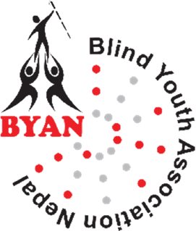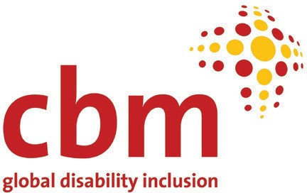

**Blind Youth Association Nepal BYAN)**

**0** Raramarga, Sukedhara 4, Kathmandu Metropolitan City, Kathmandu, Nepal

+977-01-4372160

[info@byanepal.org](mailto:info@byanepal.org) [www.byanepal.org](http://www.byanepal.org/)