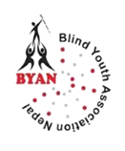 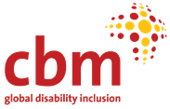

PEER EDUCATOR

**A YEAR OF EMPOWERMENT AND IMPACT**

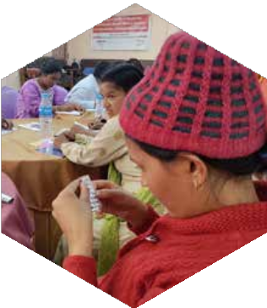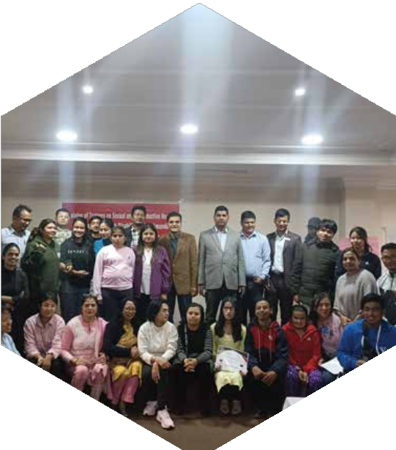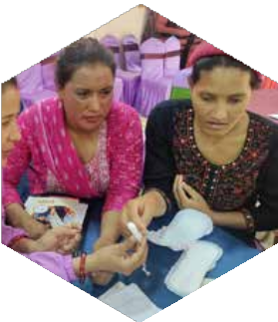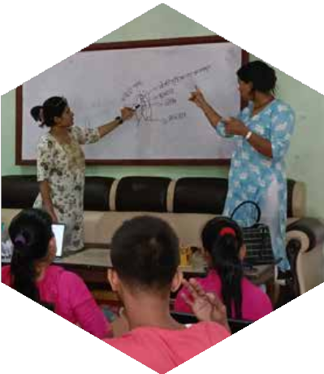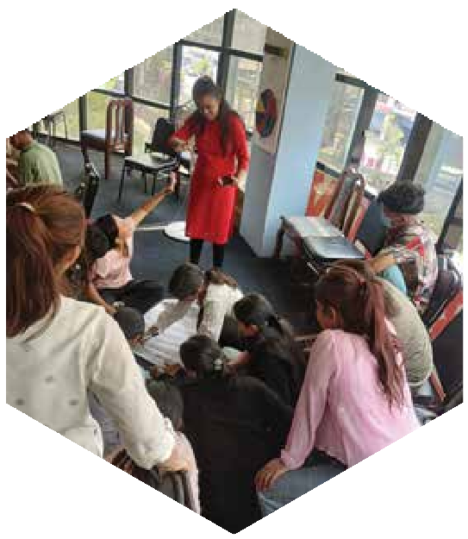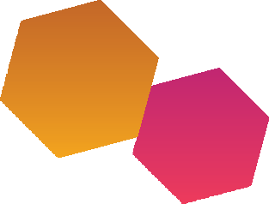



**PURPOSE OF THE DOCUMENT**

This document aims to capture the journey and achievements of the peer educators trained under the Action for Change project. It highlights their experiences in facilitating group sessions and one-on-one counseling on Sexual and Reproductive Health and Rights (SRHR) for individuals with disabilities.

**Overview:** BYAN is currently implementing The Action for Change Project (2023–2025), supported by CBM Global UK, in three districts - Kathmandu (Bagmati Province), Bara (Madhesh Province), and Surkhet (Karnali Province), with the objective of empowering persons with disabilities to exercise their rights and make informed sexual and reproductive health (SRH) choices within a supportive social, institutional, and legal environment.

**WHY IS THIS IMPORTANT:**

Sharing experiences with someone similar makes it easier to discuss sensitive topics without fear of judgment.

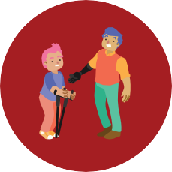

Peer educators understand the communication needs of their participants, enabling better interaction.

Participants are more likely to open up and share their challenges with someone they trust and relate to.

Peer educators, being in similar situations, can empathize deeply, making the guidance more impactful and supportive.



**WHO ARE THE PEER EDUCATOR AND WHAT ARE THEIR ROLES?**

At the start of the year, 75 persons with various disabilities (visual impairment, hearing impairment, physical disability, speech related disability, intellectual disabilities and their parents, psychosocial disability and multiple disabilities) from 3 districts underwent a 5-day ToT on SRHR to become peer educators including one-day preparatory meeting to the persons with intellectual disability and their parents. The major roles of the peer educator were to conduct a session in a pair of 2/3 peer educators and also one-to-one counseling to persons with disabilities.

Total number of Peer educators

**75**

Total number of Applications received

Kathmandu - 62, Bara - 41, Surkhet - 49

**152**

**DETAILS OF PEER EDUCATOR :**

Male and Female with Disability

**25**

**25**

**25**



10

8

12



12

14

11

Male and Female without Disability

 Kathmandu  Bara



0

0

0



3

3

2



TOTAL - 30



TOTAL - 45

 Surkhet



**SESSION**

Male and Female with Disability

**205**

**210**

**189**



70

58

69



88

101

72

Male and Female without Disability

 Kathmandu  Bara



10

9

15



42

37

33



TOTAL - 231



TOTAL - 373

 Surkhet

**COUNSELING**

Male and Female with Disability



241

209

299



182

269

167

Male and Female without Disability



2

3

18



78

21

30

 Kathmandu  Bara

 Surkhet

**502**

**505**

**514**



TOTAL - 772



TOTAL - 747

SEXUAL & GENDER MINORITIES

**2**

TOTAL NUMBER OF PERSON REACHED

**2200**

# KEY ACHIEVEMENTS

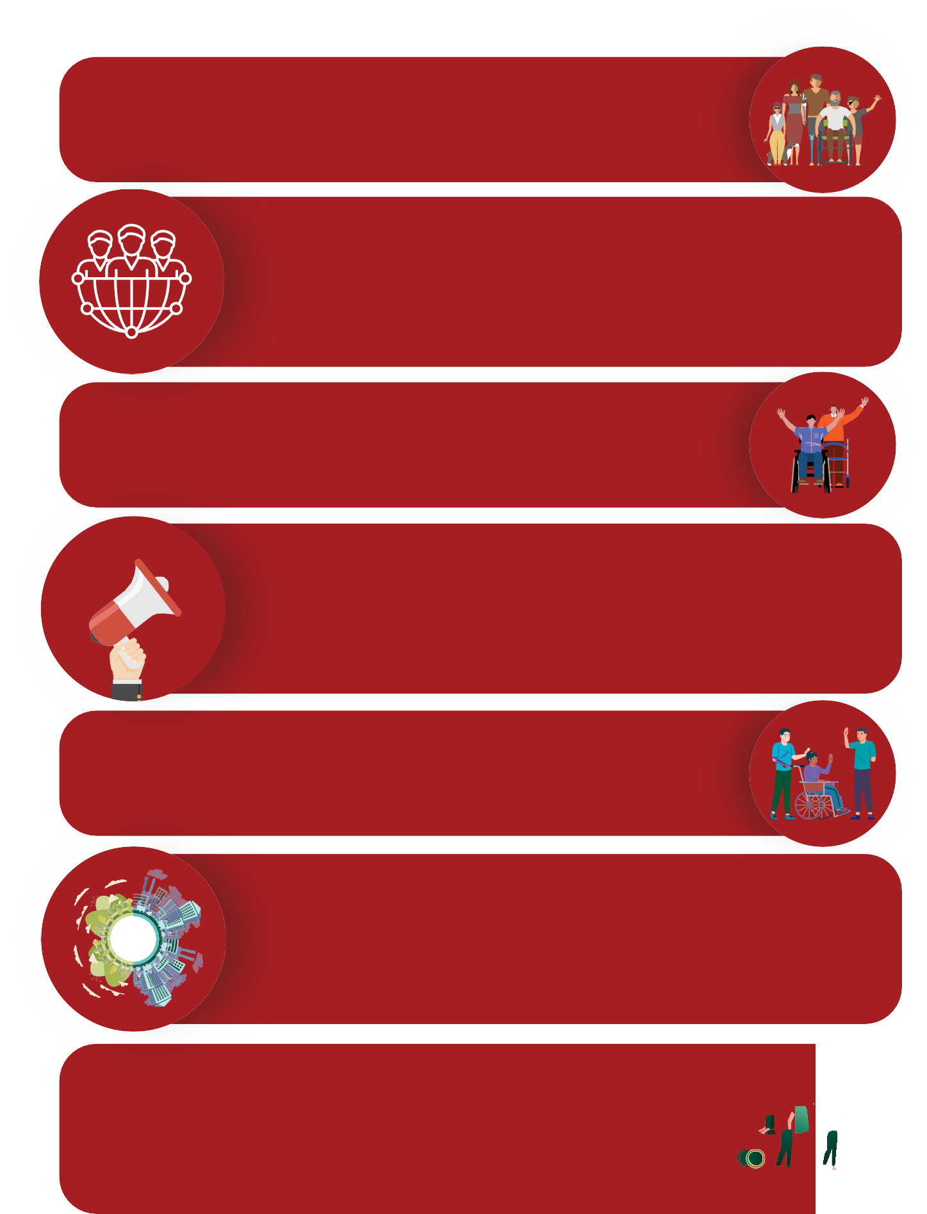

**Empowering Persons with Disabilities:** 75 peer educators, trained to facilitate SRHR sessions and counseling to persons with disabilities.

**Wide Outreach:** Conducted 30 sessions for 604 group sessions and one-on-one counseling sessions to 1,521persons with disabilities across three districts, reaching diverse participants.

**Building Confidence:** Educators transitioned from being hesitant to openly discussing and advocating for SRHR topics.

**Clearing Misconceptions:** Addressed SRHR myths and fostered awareness, enabling participants to approach health facilities and discuss personal issues.

**Skill Development:** Peer educators enhanced their advocacy, communication, and counseling skills, creating a foundation for future initiatives.

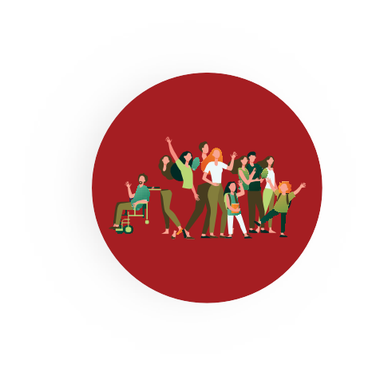**Inclusion of Marginalized Groups:** Reached individuals with disabilities and their families in urban as well as rural areas, encouraging open dialogue on SRHR, often for the first time.

**Community Engagement:** Encouraged communities to rethink the relevance of SRHR for persons with disabilities, challenging

deep-rooted stigmas.





 



**Leadership Growth:** Peer educators emerged a advocates within their communities, inspiring others with disabilities to engage and participate actively.

**PERSONAL JOURNEYS (REFLECTIONS)**

**Psychosocial Disability Male, Surkhet:** "I knew about condoms but little else about family planning. After the training, I expanded my knowledge and met others with similar struggles. I even confronted local leaders, asking why SRHR initiatives weren’t prioritized. Although they dismissed my concerns at first, I found the courage to make them listen."

**Multiple Disabilities (Low Vision & Physical) women, Surkhet:** "People doubted I could succeed as a peer educator. Despite their skepticism, I remained determined. I saw others like me realize their potential through my efforts. That gave me immense happiness, and it inspired others in my community to take action too."

**Deaf Woman, Kathmandu:** "SRHR was something I never had the chance to learn in depth. At first, I thought it would be impossible to teach others. But with practice, I improved my capacity. Now, I feel proud that I can openly discuss SRHR, even within the hearing-impaired community where such opportunities are rare. I also learned new sign language terms related to SRHR, which I never knew existed before the training and could teach to others as well."

**Blind women, Kathmandu:** “When it comes to health, we’ve all been learning about it since childhood. Back in school, I still had my vision, and I remember seeing pages in books with illustrations of male and female reproductive organs. I would even tell the teacher not to teach those pages.

Later, during grades 11 and 12, school used to distribute pads, and we, as girls, carried large bags to school, trying to ensure no one noticed that we were carrying pads. That was the extent of my thoughts and knowledge about SRHR at that time. However, now I use a menstrual cup, which I learned about through this training. I was able to bring changes in myself and share this knowledge with my family as well. Most importantly, I gained the confidence to speak up.”

**Mother of Child with Intellectual disability, Bara:** “Although I

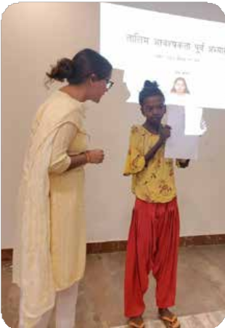studied health during my school, SRHR topic was never discussed much and no one used to talk about this as this is sensitive topic, especially for women and persons with disabilities. After the training and working as peer educator, I had to take session about SRHR and also do counseling, I was able to talk about SRHR topic with other people which eventually changed my thinking.” “The first time I saw a tampon somewhere, I genuinely thought it was a cotton thread for lighting lamp. It

was only after attending the training that I realized it is a product

used during menstruation.”

**Intellectual Disability, Kathmandu:** "During the counseling sessions, I discovered my ability to listen and empathize deeply. This was something I hadn’t realized about myself before, and it gives me hope for a future in this field."

**Physical Disability Male, Kathmandu:** "Many parents questioned why we needed to teach SRHR to persons with disabilities, saying they wouldn’t marry anyway. Despite this, I persisted, teaching them about disabilities, the importance of identity cards, and basic SRHR concepts. It was challenging but rewarding."

# REFLECTIONS AND LESSON LEARNED:

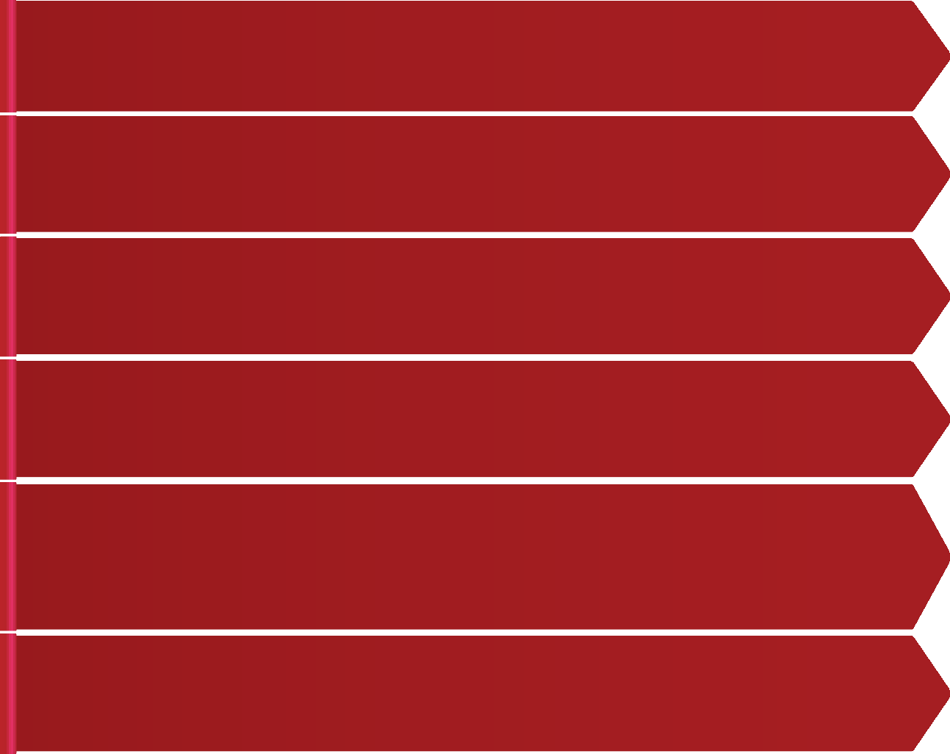

Accessible IEC materials enhance learning and engagement for persons with disabilities.

Physical and communication accessibility fosters

inclusivity and eﬀective participation.

Continuous mentorship builds peer educators

confidence and skills.

Peer educators gained confidence, broke stereotypes,

and inspired others in their communities.

Seeing peer educators succeed and thrive in their roles served as a powerful motivator and role model for others with disabilities.

Community support significantly enhanced the impact

and acceptance of peer educators roles.

**ACKNOWLEDGEMENT TO PEER EDUCATOR**

We sincerely thank the peer educators for their dedication and resilience in promoting SRHR among persons with disabilities. Their tireless efforts have broken barriers, inspired change, and left a lasting impact on their communities.



**BLIND YOUTH ASSOCIATION NEPAL (BYAN)**

Address: Sukedhara - 4, Kathmandu, Nepal Email: info@byanepal.org,byanepal@gmail.com Website: [www.byanepal.org](http://www.byanepal.org/)

Blindyouthnepal